**A CRM APPLICATION FOR WHOLESALE RICE MILL**

**Submitted By:**

Divyanshu Nautiyal

**Email:** divyanshunautiyal10@gmail.com

**Milestone 1-Salesforce**

**Activity 1: Creating Developer Account:**

* **Visited the Salesforce Developer Sign-Up Page**

I opened my web browser and navigated to the [Salesforce Developer Sign-Up Page.](https://developer.salesforce.com/signup)

* **Filled Out the Sign-Up Form**

I entered the following details in the sign-up form:

* + **First Name:** Divyanshu
  + **Last Name:** Nautiyal
  + **Email Address:** divyanshunautiyal10@gmail.com
  + **Job Role:** Developer
  + **Company:** Graphic Era Deemed to be University
  + **Country:** India
  + **Postal Code:**248001
  + **Username:** divyanshu@acc.in
* **Submitted the Form**

After filling out the form, I clicked the "Sign Me Up" button to submit my information.

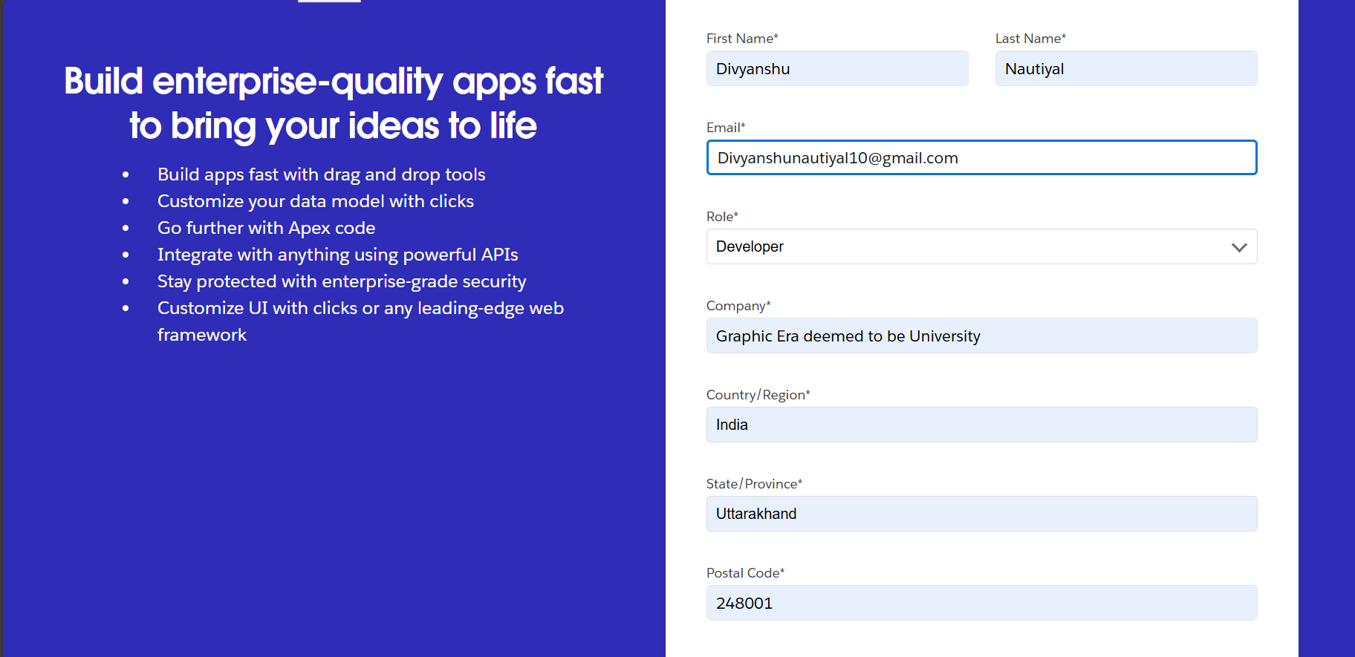

**Activity 2: Account Activation:**

**Checked for Confirmation Email**

I checked my email inbox for a confirmation email from Salesforce. Upon receiving it, I clicked the confirmation link in the email to activate my Salesforce Developer account.

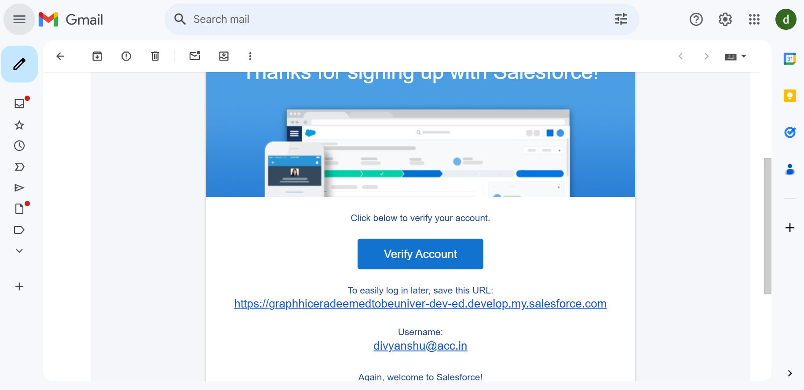

**Milestone 2- Object**

**Activity 1: Create Supplier Object**

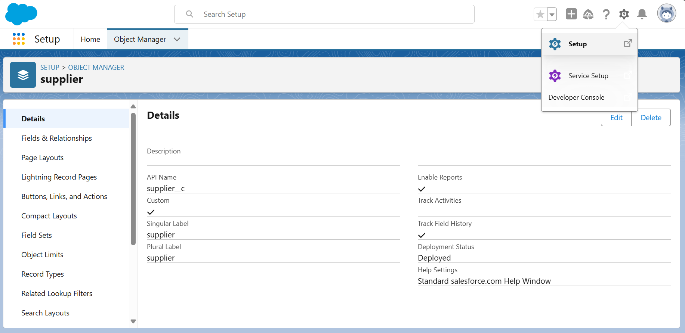

1. **Navigated to Object Manager**

From the setup page, I clicked on "Object Manager."

1. **Created a New Custom Object**

I clicked on "Create" and then selected "Custom Object."

1. **Entered Object Details**
2. **Label Name:** Supplier
3. **Plural Label Name:** Suppliers
4. **Record Name:** Supplier Name
   1. **Data Type:** Text
5. **Configured Object Settings**

I selected "Allow Reports" and "Track Field History" options, and enabled "Allow Search."

1. **Saved the Object**

I clicked on the "Save" button to create the Supplier object.

**Activity 2: Create Rice Mill Object**

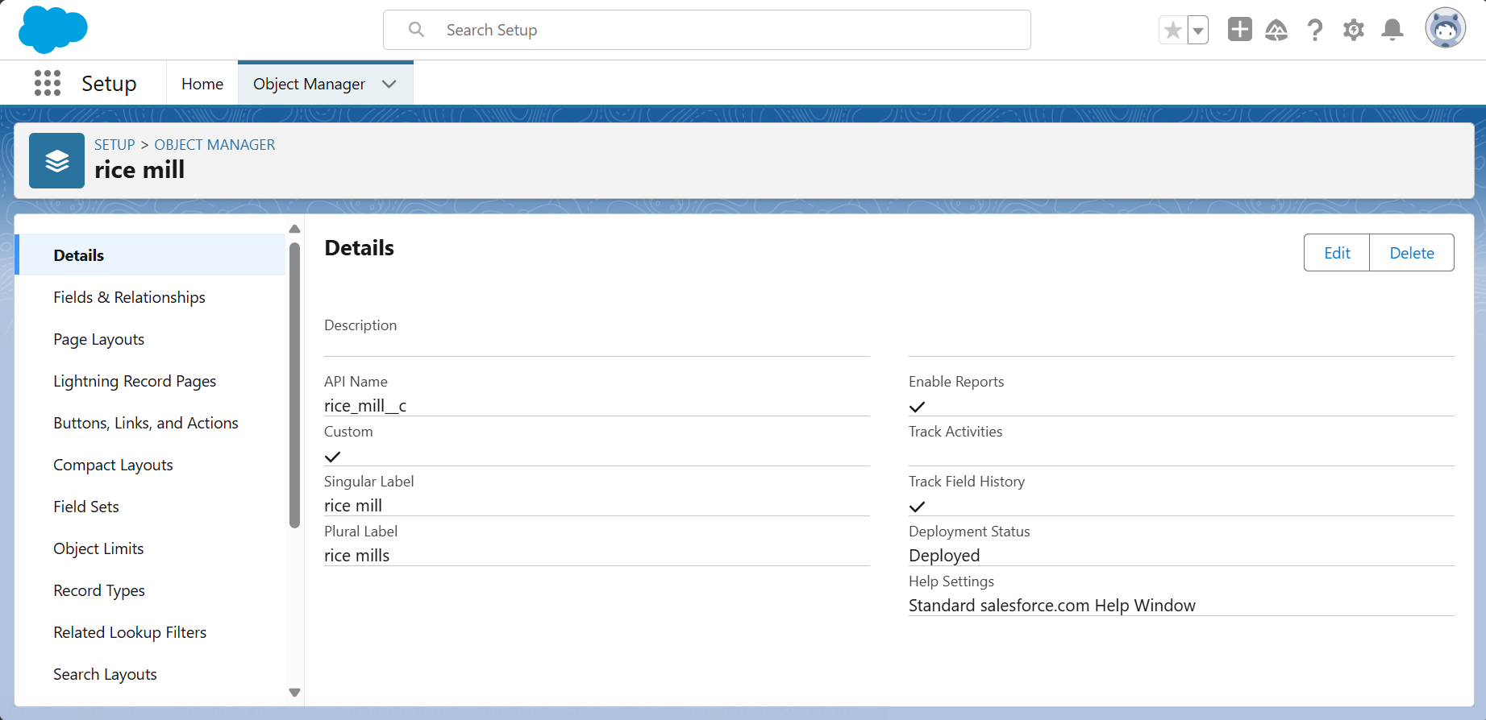

1. **Navigated to Object Manager**

From the setup page, I clicked on "Object Manager."

1. **Created a New Custom Object**

I clicked on "Create" and then selected "Custom Object."

1. **Entered Object Details**
2. **Label Name:** Rice Mill
3. **Plural Label Name:** Rice Mills
4. **Record Name:** Rice Mill Number
5. **Data Type:** Auto Number
6. **Display Format:** rice-{000}
   1. **Starting Number:** 1
7. **Configured Object Settings**

I selected "Allow Reports" and "Track Field History" options, and enabled "Allow Search."

1. **Saved the Object**

I clicked on the "Save" button to create the Rice Mill object.

**Activity 3: Create Consumer Object**

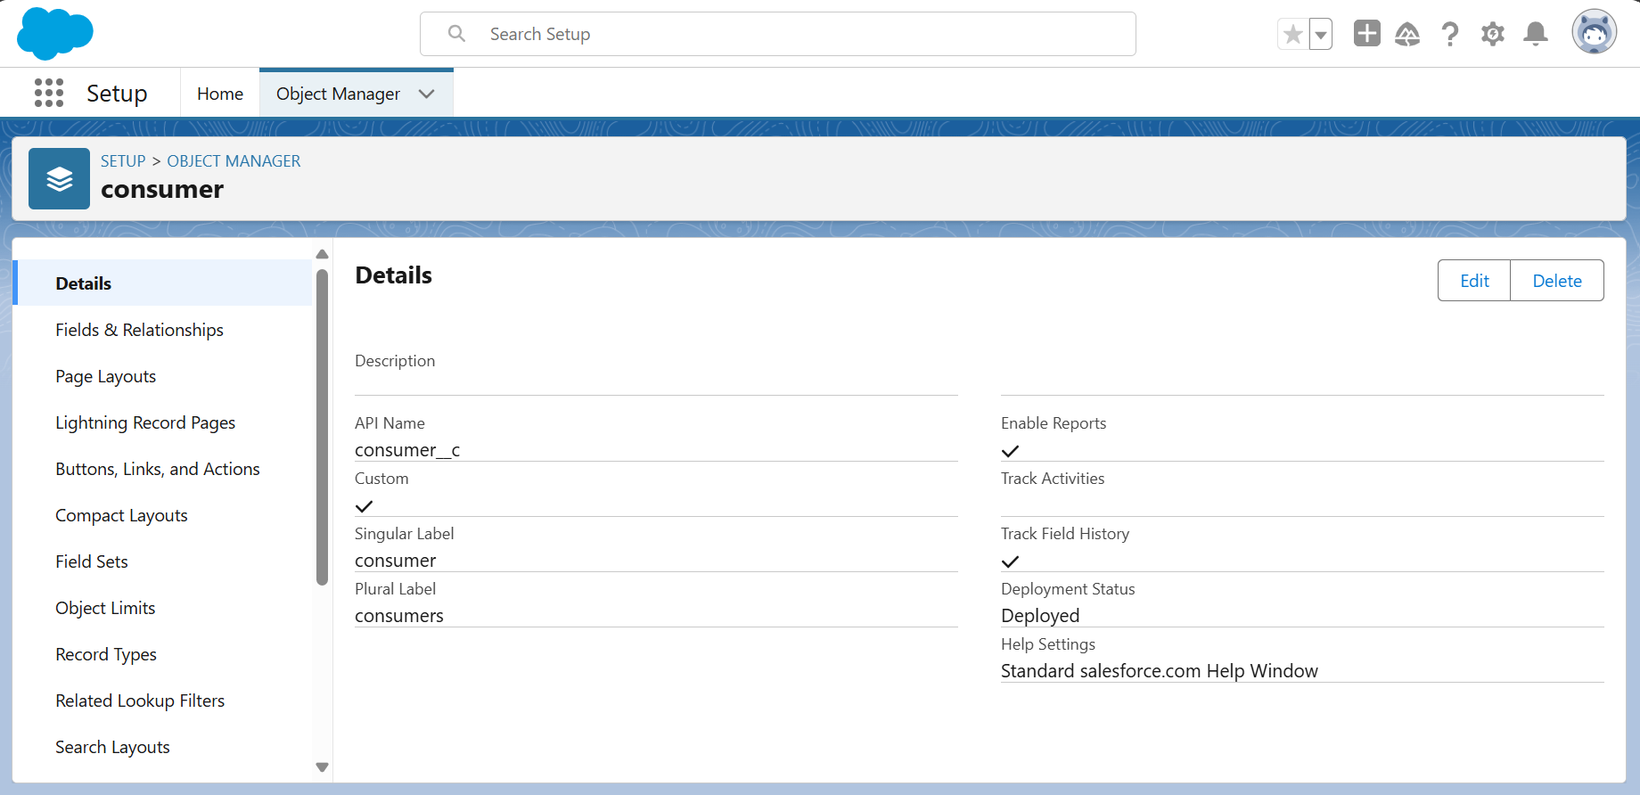

1. **Followed the Steps from Activity 2**

I followed the same steps as mentioned in Activity 2 for creating the Consumer object.

1. **Entered Object Details**
2. **Label Name:** Consumer
3. **Plural Label Name:** Consumers
4. **Record Name:** Consumer Number
5. **Data Type:** Auto Number
6. **Display Format:** consumers-{000}
   1. **Starting Number:** 1
7. **Configured Object Settings**

I selected "Allow Reports" and "Track Field History" options, and enabled "Allow Search."

1. **Saved the Object**

I clicked on the "Save" button to create the Consumer object.

**Activity 4: Create Rice Details Object**

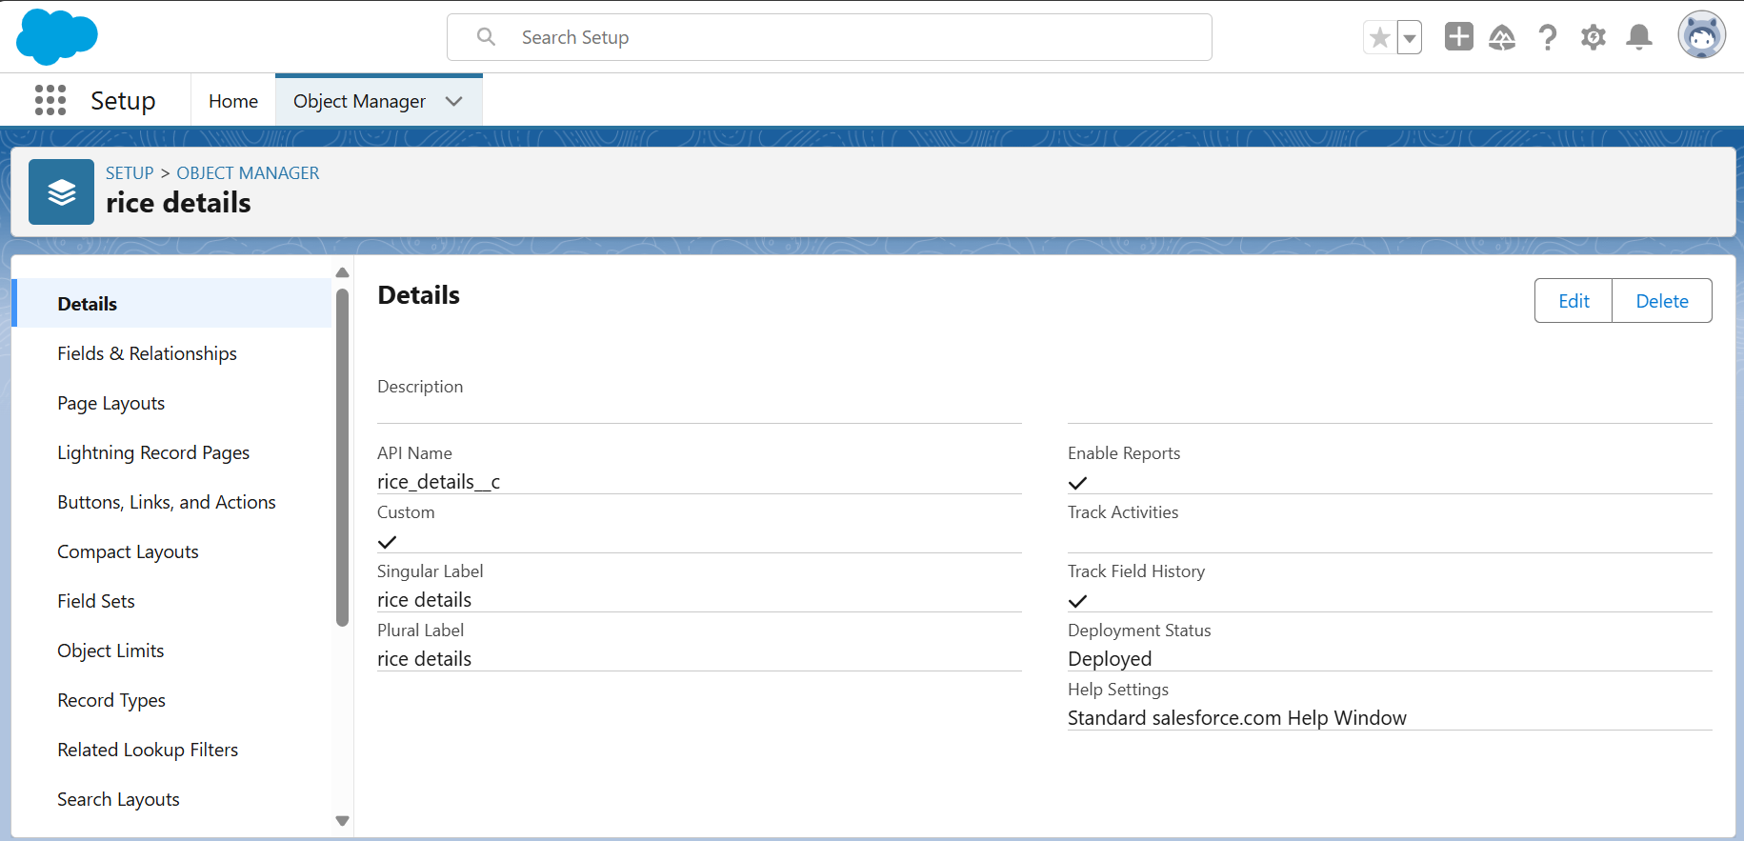

1. **Followed the Steps from Activity 2**

I followed the same steps as mentioned in Activity 2 for creating the Rice Details object.

1. **Entered Object Details**
2. **Label Name:** Rice Details
3. **Plural Label Name:** Rice Details
4. **Record Name:** Rice Detail Number
5. **Data Type:** Auto Number
6. **Display Format:** rice-{000}
   1. **Starting Number:** 1
7. **Configured Object Settings**

I selected "Allow Reports" and "Track Field History" options, and enabled "Allow Search."

1. **Saved the Object**

I clicked on the "Save" button to create the Rice Details object.

**Milestone 3- Tabs**

**Activity 1: Creating Custom Tabs**

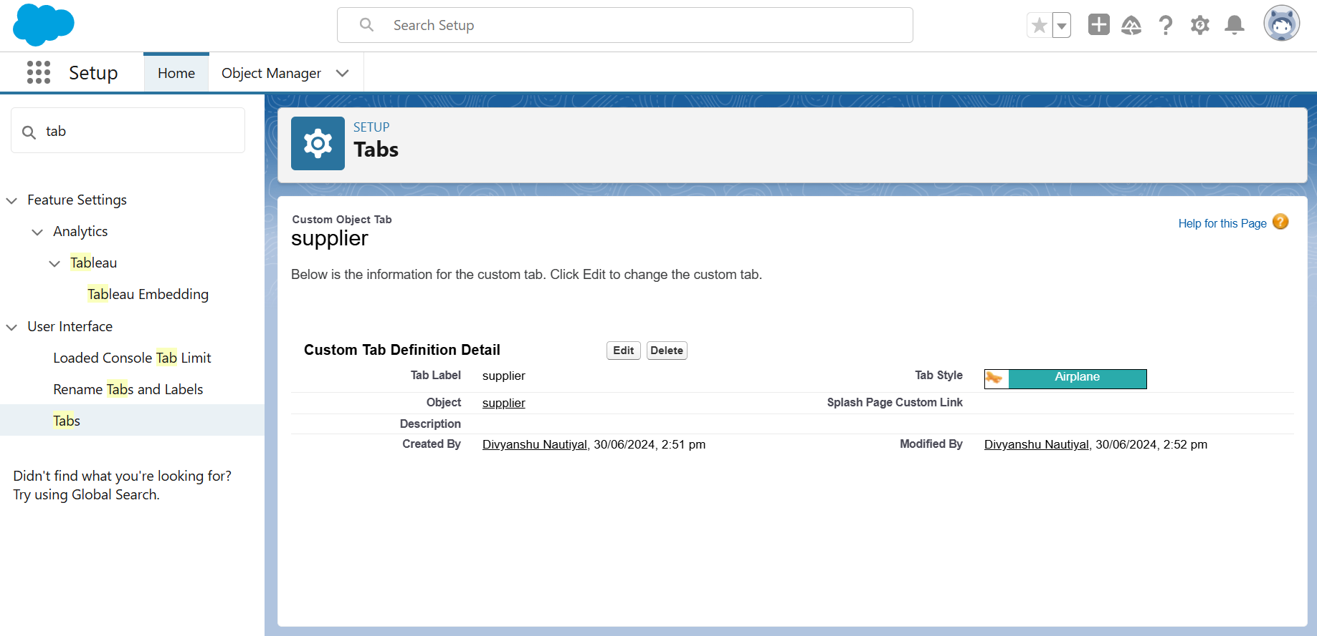

1. **Creating a Tab for Supplier Navigated to Tabs Setup**

From the setup page, I typed "Tabs" in the Quick Find bar and clicked on "Tabs."

1. **Created a New Custom Object Tab**

I clicked on "New" under the Custom Object Tabs section.

1. **Selected Object and Tab Style**
2. **Selected Object:** Supplier
3. **Selected Tab Style:** Airplane
4. Clicked "Next" on the Add to Profiles page, keeping it as default.
   1. Clicked "Next" on the Add to Custom App page, unchecking the "Include Tab" option.
5. **Finalized Tab Settings**

Ensured that the "Append tab to users' existing personal customizations" option was checked.

1. **Saved the Tab**

I clicked on the "Save" button to create the Supplier tab.

**Creating a Tab for Consumer**

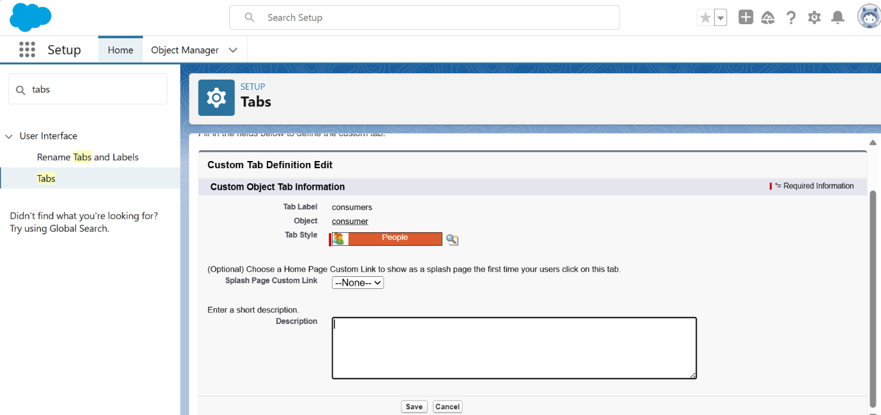

1. **Navigated to Tabs Setup**

From the setup page, I typed "Tabs" in the Quick Find bar and clicked on "Tabs."

1. **Created a New Custom Object Tab**

I clicked on "New" under the Custom Object Tabs section.

1. **Selected Object and Tab Style**
   1. **Selected Object:** Consumer o **Selected Tab Style:** people

o Clicked "Next" on the Add to Profiles page, keeping it as default.

o Clicked "Next" on the Add to Custom App page, unchecking the "Include Tab" option.

1. **Finalized Tab Settings**

Ensured that the "Append tab to users' existing personal customizations" option was checked.

1. **Saved the Tab**

I clicked on the "Save" button to create the Consumer tab.

**Creating a Tab for Rice Mill**

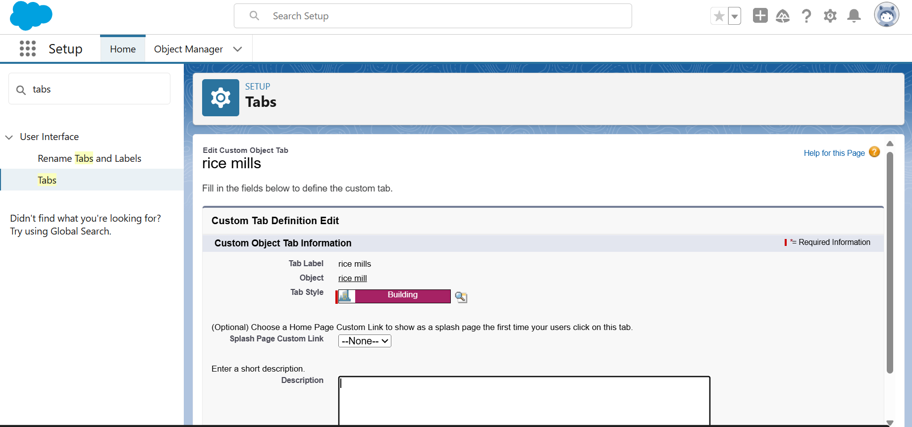

1. **Navigated to Tabs Setup**

From the setup page, I typed "Tabs" in the Quick Find bar and clicked on "Tabs."

1. **Created a New Custom Object Tab**

I clicked on "New" under the Custom Object Tabs section.

1. **Selected Object and Tab Style**
   1. **Selected Object:** Rice Mill o **Selected Tab Style:** Building

o Clicked "Next" on the Add to Profiles page, keeping it as default.

o Clicked "Next" on the Add to Custom App page, unchecking the "Include Tab" option.

1. **Finalized Tab Settings**

Ensured that the "Append tab to users' existing personal customizations" option was checked.

1. **Saved the Tab**

I clicked on the "Save" button to create the Rice Mill tab.

**Creating a Tab for Rice Details**

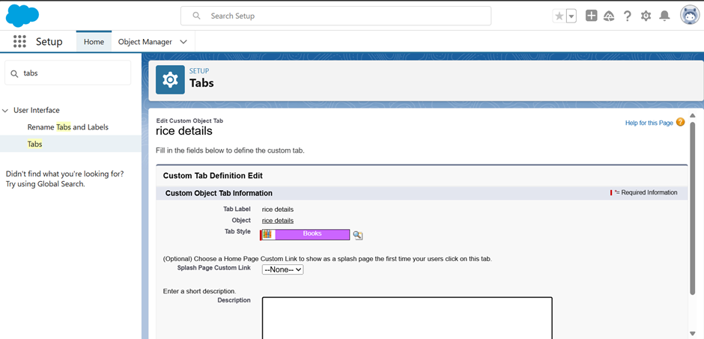

1. **Navigated to Tabs Setup**

From the setup page, I typed "Tabs" in the Quick Find bar and clicked on "Tabs."

1. **Created a New Custom Object Tab**

I clicked on "New" under the Custom Object Tabs section.

1. **Selected Object and Tab Style**
   1. **Selected Object:** Rice Details o **Selected Tab Style:** Books

o Clicked "Next" on the Add to Profiles page, keeping it as default.

o Clicked "Next" on the Add to Custom App page, unchecking the "Include Tab" option.

1. **Finalized Tab Settings**

Ensured that the "Append tab to users' existing personal customizations" option was checked.

1. **Saved the Tab**

I clicked on the "Save" button to create the Rice Details tab.

**Milestone 4- The Lightning App**

**Activity 1: Create a Lightning App**

**Creating a Lightning App Page**

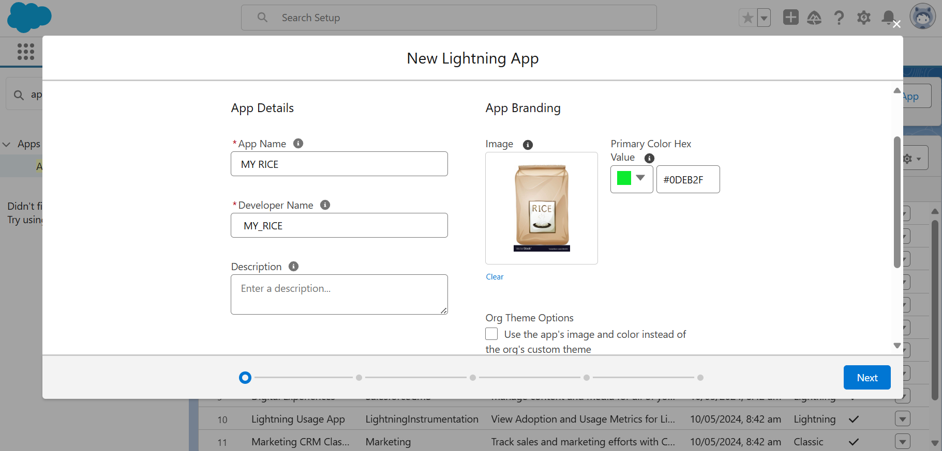

1. **Navigated to App Manager**

From the setup page, I searched for "App Manager" in the Quick Find bar and selected "App Manager."

1. **Created a New Lightning App**

I clicked on "New Lightning App."

1. **Filled Out App Details**
   1. **App Name:** MY RICE
   2. Clicked "Next."
2. **Configured App Options**
   1. Kept all options on the App Options page as default.
   2. Clicked "Next."
3. **Configured Utility Items**
   1. Kept all options on the Utility Items page as default.
   2. Clicked "Next."
4. **Uploaded a Photo for the App**

I uploaded a photo that is related to the MY RICE app.

1. **Added Navigation Items**
   1. I selected the following items from the search bar and moved them using the arrow button:
      * Supplier
      * Rice Mill
      * Consumer
      * Rice Details

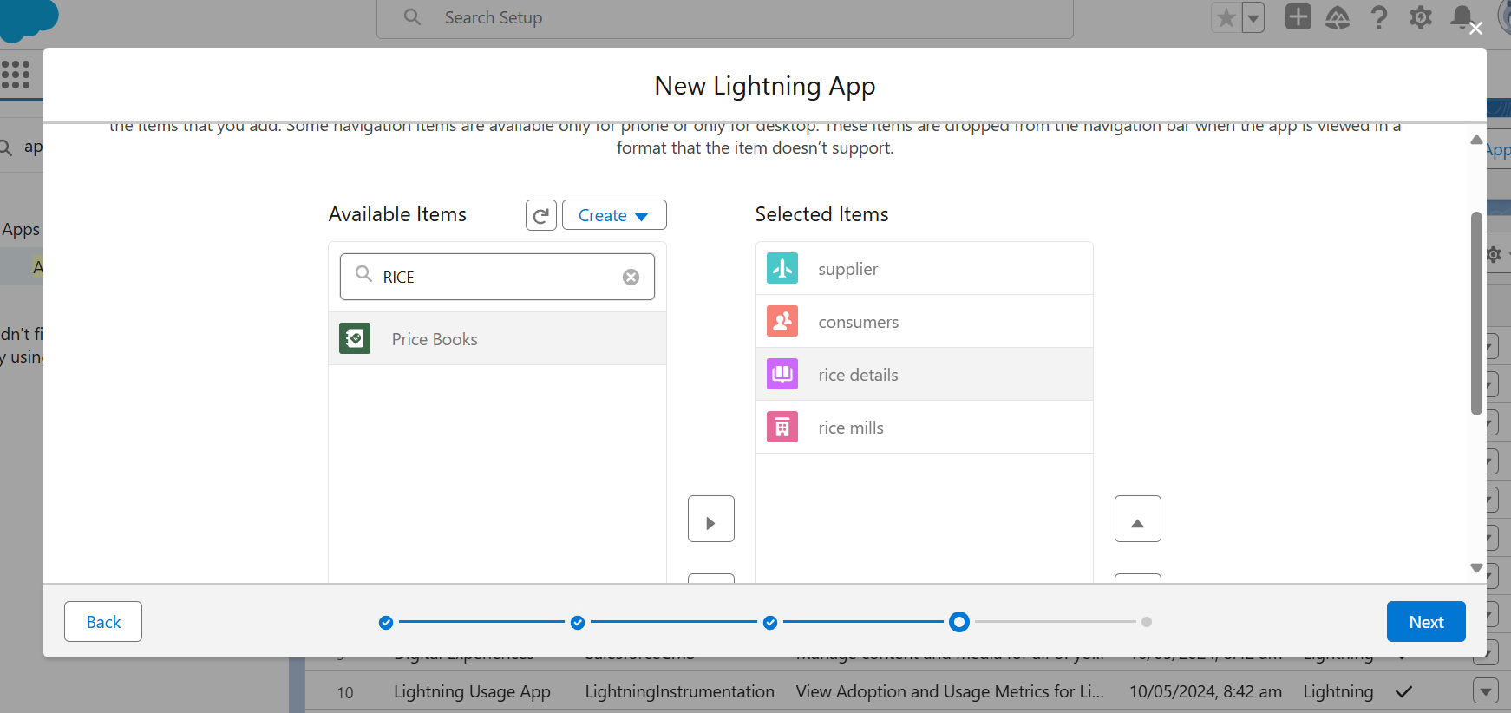

1. **Added User Profiles**
2. I searched for "System Administrator" in the search bar. o Clicked on the arrow button to add the profile.

* Clicked "Save & Finish."

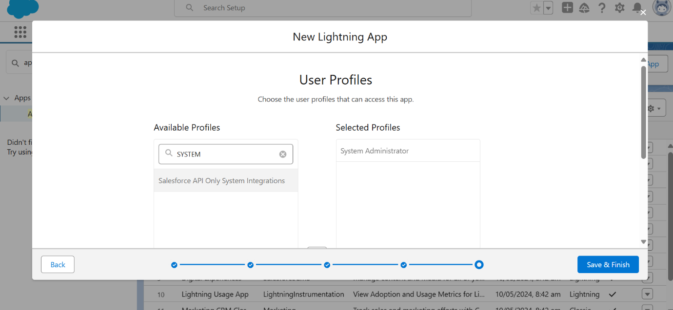

**Final Output of MY RICE app (Screenshot)**

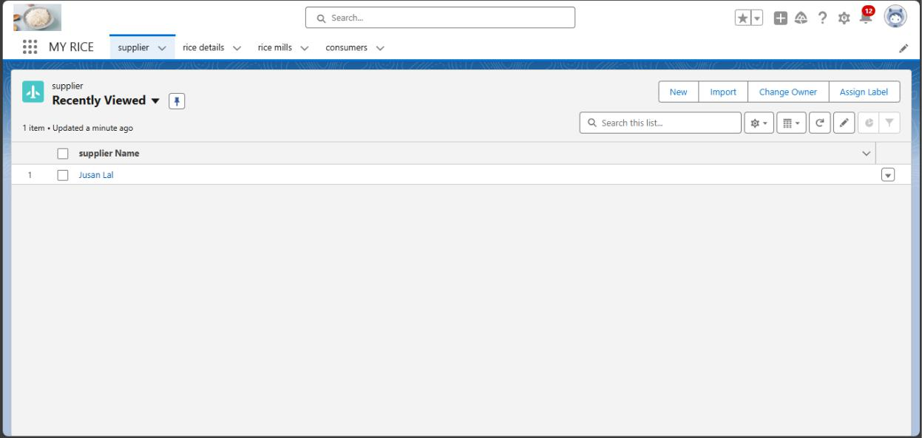

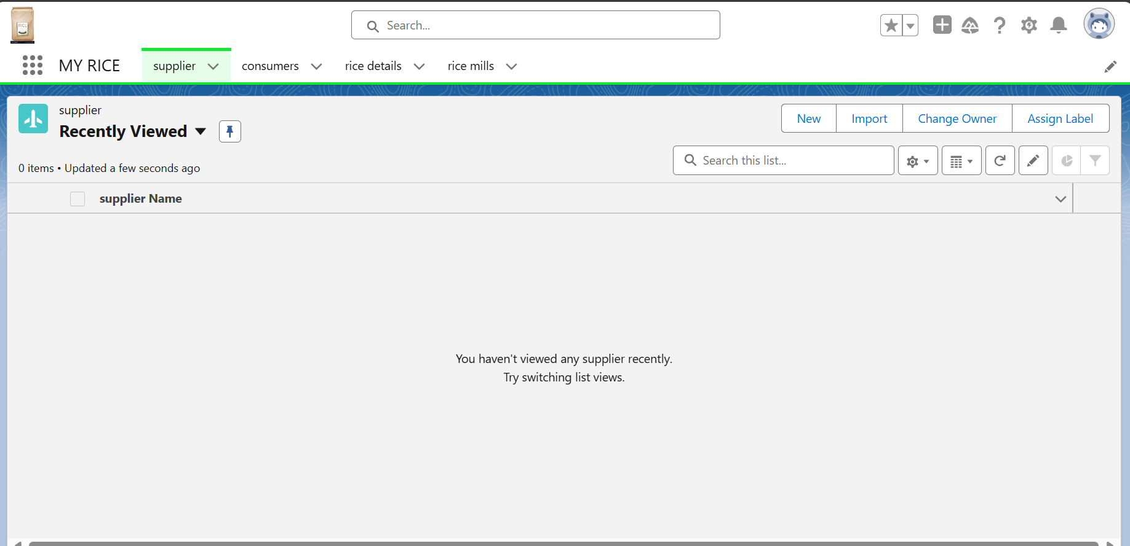

**Milestone 5 : Fields**

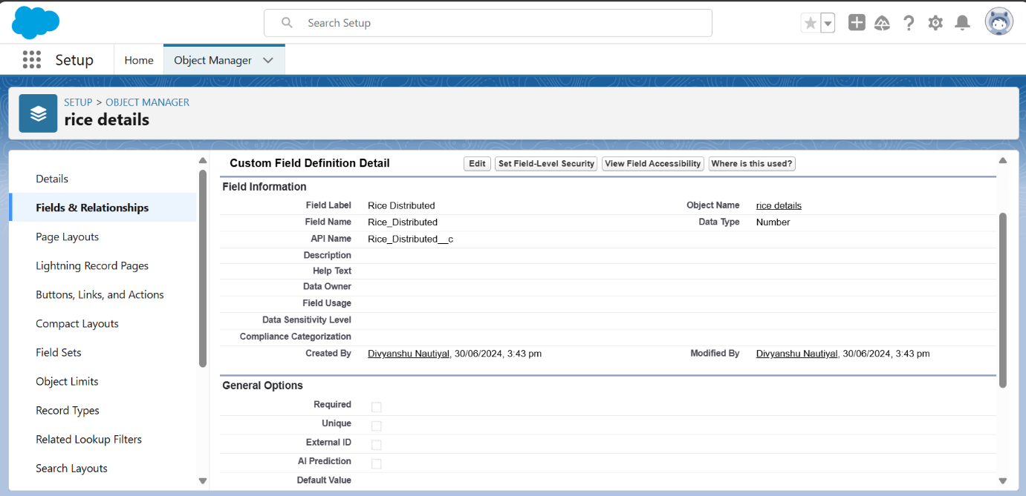

**Activity 1: Creating the Number Field in Rice Details Object**

1. **Navigated to Rice Details Object**

From the setup page, I clicked on "Object Manager," then from the dropdown, I selected and edited the Rice Details object.

1. **Created a New Field**

I clicked on "Fields & Relationships" and then clicked on "New."

1. **Selected Data Type**

I selected "Number" as the data type and clicked "Next."

1. **Entered Field Details**
2. **Field Label:** Rice Distributed

o **Length:** 5

o The Field Name was auto-populated.

o Clicked "Next," "Next," and then "Save."

**Activity 2: Creating Junction Object: Rice Details with Supplier & Rice Mill**

**Creating Master-Detail Relationship with Supplier**

1. **Navigated to Rice Details Object**

From the setup page, I clicked on "Object Manager," then from the dropdown, I selected and edited the Rice Details object.

1. **Created a New Field**

I clicked on "Fields & Relationships" and then clicked on "New."

1. **Selected Data Type**

I selected "Master-Detail Relationship" as the data type and clicked "Next."

1. **Selected Related Object**

I selected "Supplier" as the related object and clicked "Next."

1. **Entered Field Details**
2. 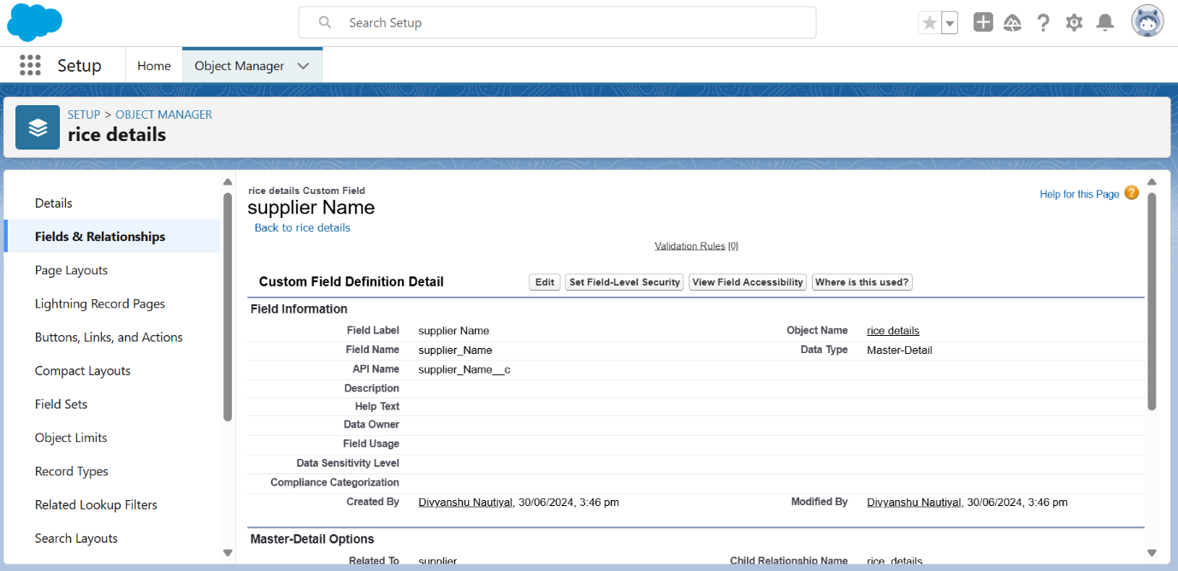**Field Label:** Supplier Name
3. Clicked "Next," "Next," and then "Save & New."

**Creating Master-Detail Relationship with Rice Mill**

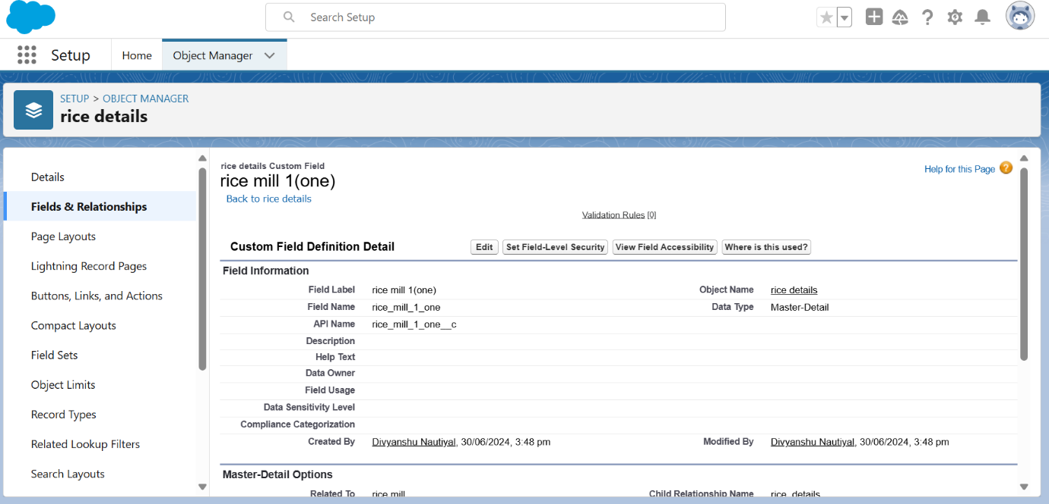

1. **Repeated Steps for Rice Mill**

I followed the same steps from 1 to 3.

1. **Selected Related Object**

I selected "Rice Mill" as the related object and clicked "Next."

1. **Entered Field Details**
2. **Field Label:** Rice Mill 1 (One)
3. Clicked "Next," "Next," and then "Save."

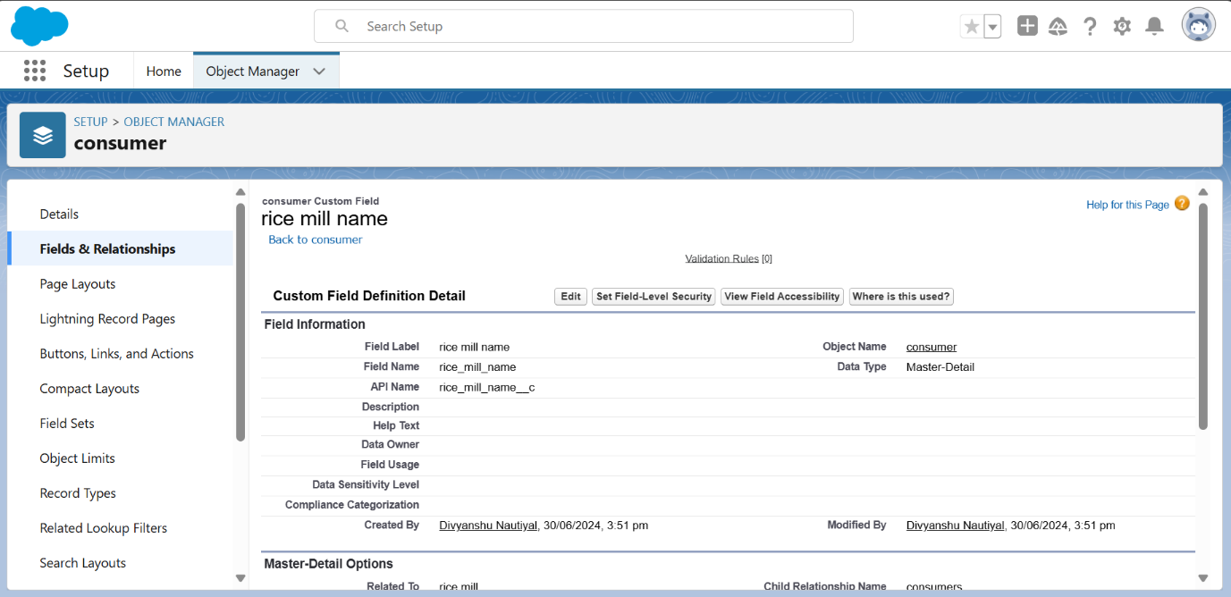**Activity 3: Creating a Master-Detail Relationship between Consumer & Rice Mill Object**

1. **Navigated to Consumer Object**

From the setup page, I clicked on "Object Manager," then from the dropdown, I selected and edited the Consumer object.

1. **Created a New Field**

I clicked on "Fields & Relationships" and then clicked on "New."

1. **Selected Data Type**

I selected "Master-Detail Relationship" as the data type and clicked "Next."

1. **Selected Related Object**

I selected "Rice Mill" as the related object.

1. **Entered Field Details**
2. **Field Label:** Rice Mill Name
3. Clicked "Next," "Next," and then "Save."

**Activity 4: Creating the Roll-Up Summary Field**

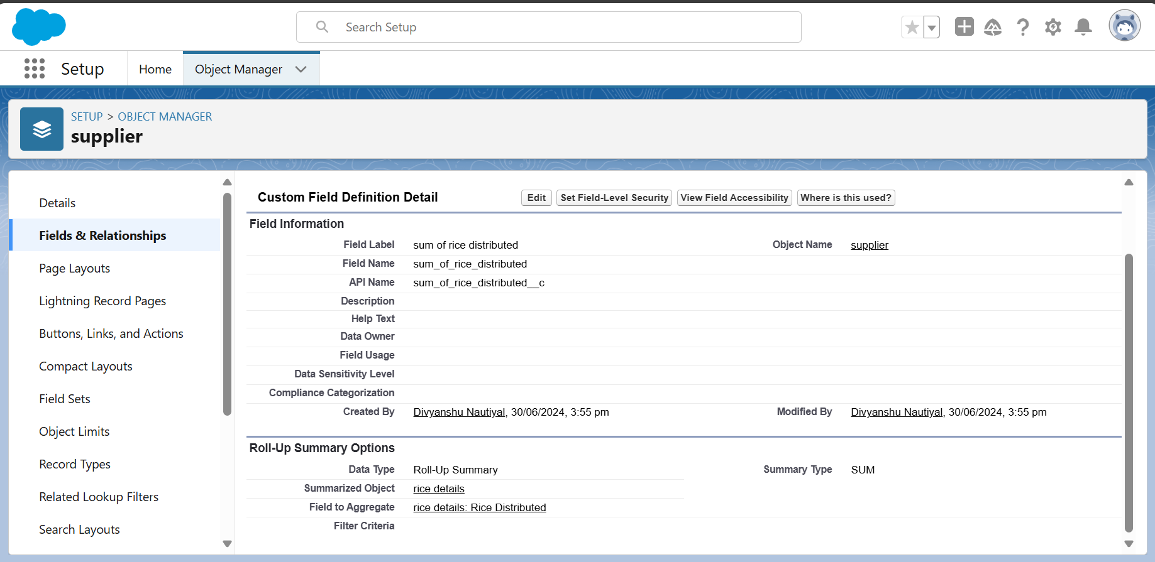

**Creating Roll-Up Summary on Supplier Object**

1. **Navigated to Supplier Object**

From the setup page, I clicked on "Object Manager," typed "Supplier" in the search bar, and clicked on the object.

1. **Created a New Field**

I clicked on "Fields & Relationships" and then clicked on "New."

1. **Selected Data Type**

I selected "Roll-Up Summary" as the data type and clicked "Next."

1. **Entered Field Details**
   1. **Field Label:** Sum of Rice Distributed
   2. The Field Name was auto-generated.
   3. Clicked "Next."
2. **Configured Roll-Up Summary**
   1. **Summarized Object:** Rice Details
3. **Roll-Up Type:** Sum
4. **Field to Aggregate:** Rice Distributed
5. Clicked "Next," "Next," and then "Save."

**Creating Roll-Up Summary on Rice Mill Object**

1. **Repeated Steps for Rice Mill Object** I followed the same steps from 1 to 3.
2. **Entered Field Details**
   1. **Field Label:** Rice Distributed to Shops
   2. 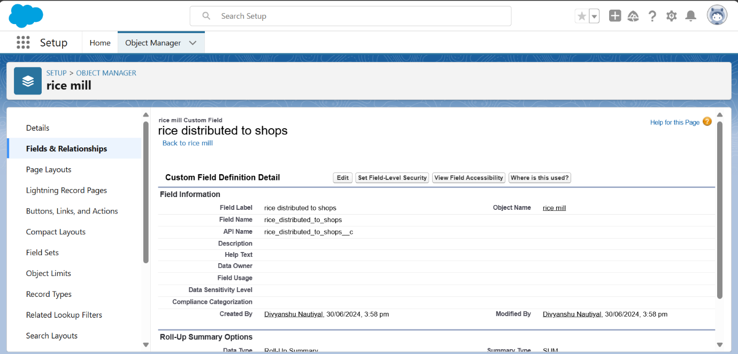The Field Name was auto-generated.
   3. Clicked "Next."
3. **Configured Roll-Up Summary**
   1. **Summarized Object:** Rice Details
4. **Roll-Up Type:** Sum
5. **Field to Aggregate:** Rice Distributed
6. Clicked "Next," "Next," and then "Save."

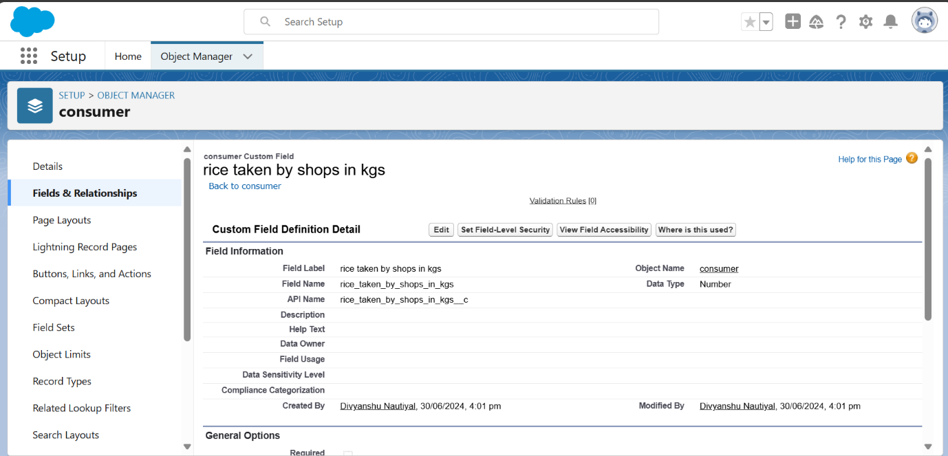**Creating the Field "Rice Taken by Shops" in Consumer Object**

1. I created "Rice Taken by Shops in kgs" field in Consumer Object at activity 4 point number 9.
2. **Repeated Steps for Rice Mill Object** I followed the same steps from 1 to 3.
3. **Entered Field Details**
4. **Field Label:** Rice Taken by Shops in kgs
   1. The Field Name was auto-generated.
   2. Clicked "Next."
5. **Configured Roll-Up Summary**
   1. **Summarized Object:** Consumer
6. **Roll-Up Type:** Sum
7. **Field to Aggregate:** Rice Taken in Shops o Clicked "Next," "Next," and then "Save."

**Activity 5: Creating Fields in Rice Details Object**

1. **Navigated to Rice Details Object**

From the setup page, I clicked on "Object Manager," then from the dropdown, I selected and edited the Rice Details object.

1. **Created a New Field**

I clicked on "Fields & Relationships" and then clicked on "New."

1. **Selected Data Type**

I selected "Number" as the data type and clicked "Next."

1. **Entered Field Details**
2. **Field Label:** Supplier Name

o **Length:** 5

o The Field Name was auto-populated.

* Clicked "Next," "Next," and then "Save."

**Activity 6: Creating Fields in Rice Mill Object**

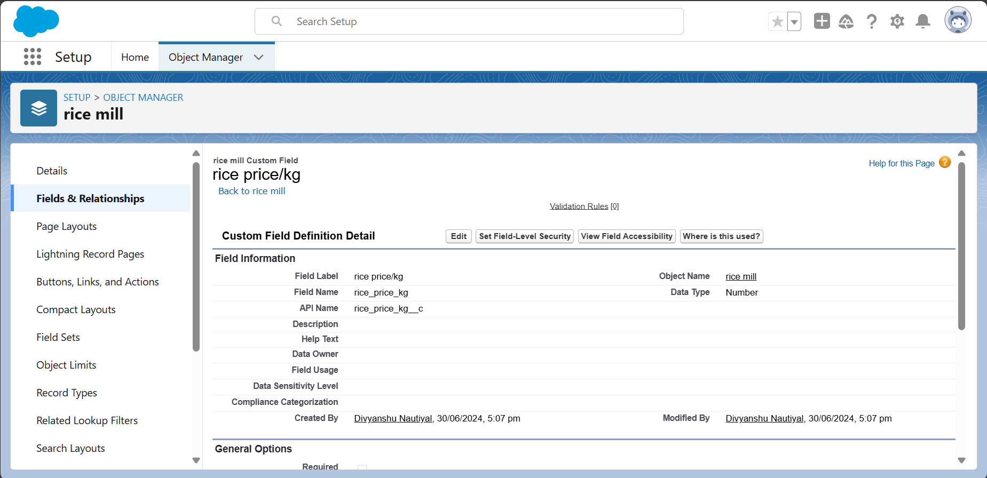

1. **Selected Data Type**

I selected "Number" as the data type and clicked "Next."

1. **Entered Field Details**
2. **Field Label:** Rice Price/Kg

o **Length:** 5

* Clicked "Next," "Next," and then "Save."

**Activity 7: Creating Fields in Consumer Object**

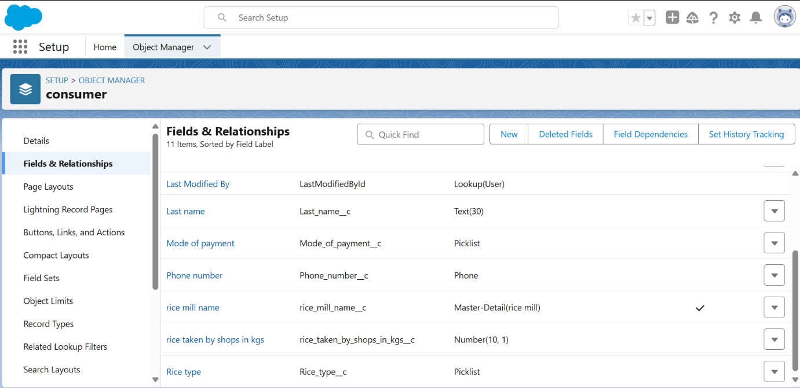

1. **Field Details**

1. **First Name:** Text

o **Last Name:** Text

o **Phone Number:** Phone

o **Email:** Email

o **Rice Taken by Shops:** Number (Length = 10)

o **Rice Type:** Picklist

* + Basmati
  + Normal Rice

1. **Mode of Payment:** Picklist
   * Credit Card
   * Debit Card
   * Net Banking
   * UPI
   * Cash

**Activity 8: Creating Cross-Object Formula Field in Consumer Object**

**Creating "Amount Paid" Formula Field**

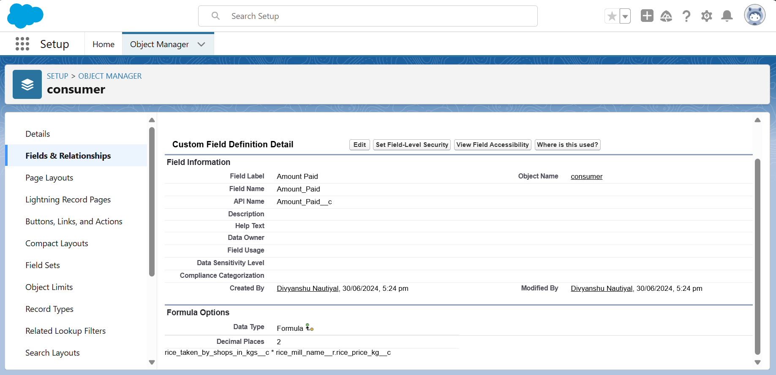

1. **Navigated to Consumer Object**

From the setup page, I clicked on "Object Manager," typed "Consumer" in the search bar, and clicked on the object.

1. **Created a New Field**

I clicked on "Fields & Relationships" and then clicked on "New."

1. **Selected Data Type**

I selected "Formula" as the data type and clicked "Next."

1. **Entered Field Details**
   1. **Field Label:** Amount Paid
   2. **Field Name:** Amount Paid
   3. **Formula Return Type:** Number
   4. Clicked "Next."
2. **Inserted Formula**
   1. Formula: rice_taken_by_shops__c *

rice_mill_name__r.rice_price_kg__c

1. Clicked "Check Syntax" and then "Save."

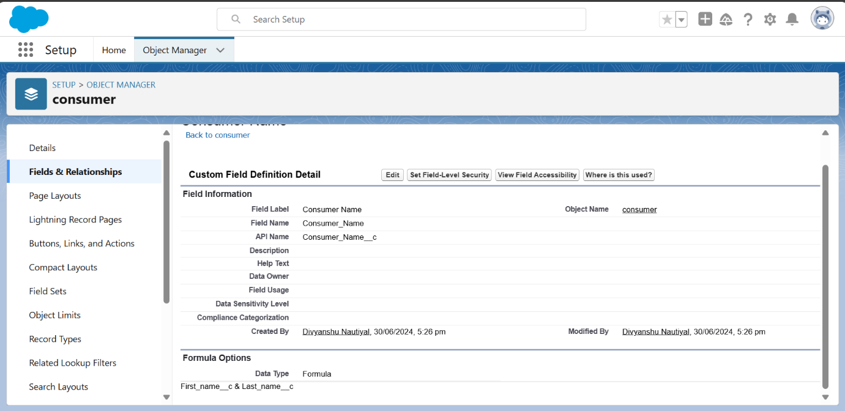**Creating "Consumer Name" Formula Field**

1. **Repeated Steps for Consumer Name** I followed the same steps from 1 to 3.
2. **Entered Field Details**
   1. **Field Label:** Consumer Name
   2. **Field Name:** Consumer Name
   3. **Formula Return Type:** Text
   4. Clicked "Next."
3. **Inserted Formula**
   1. Formula: First_Name__c + ' ' + Last_Name__c
   2. Clicked "Check Syntax" and then "Save."

**Activity 9: Creating the Validation Rule for Phone Number Field in Consumer Object**

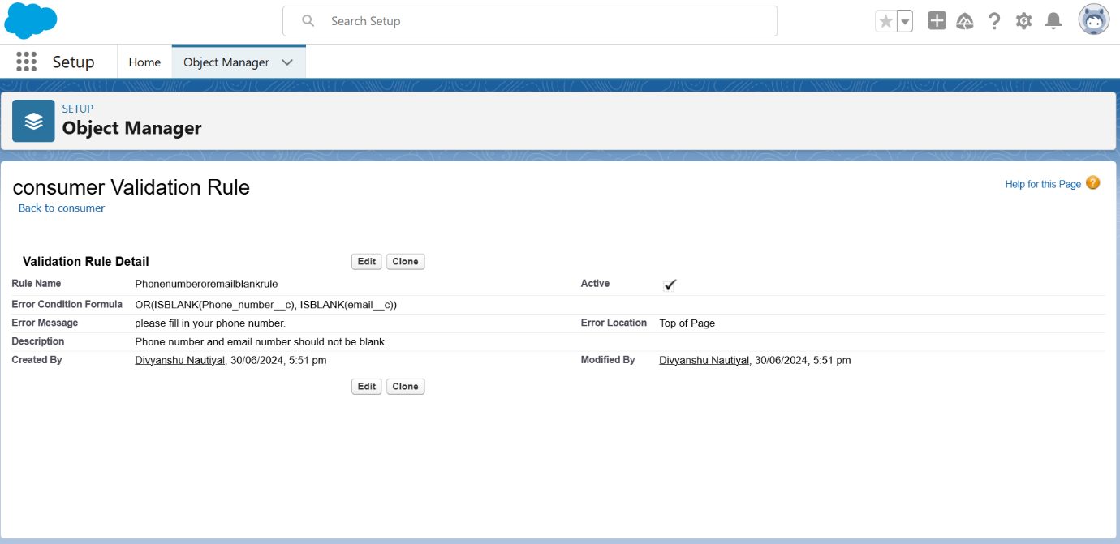

1. **Navigated to Consumer Object**

From the setup page, I clicked on "Object Manager," then from the dropdown, I selected and edited the Consumer object.

1. **Created a New Validation Rule**

I clicked on "Validation Rules" and then clicked "New."

1. **Entered Rule Details**
2. **Rule Name:** Phonenumberoremailblankrule
3. **Description:** Phone number and email number should not be blank.
   1. **Formula:** OR(ISBLANK(phone_number__c), ISBLANK(email__c))
   2. Clicked "Check Syntax."
4. **Configured Error Message**
   1. **Error Message:** Please fill in your phone number.
5. **Error Location:** Top of Page o Clicked "Save."

**Milestone 6 : Page layouts**

**Activity 1: Creating the Page Layout**

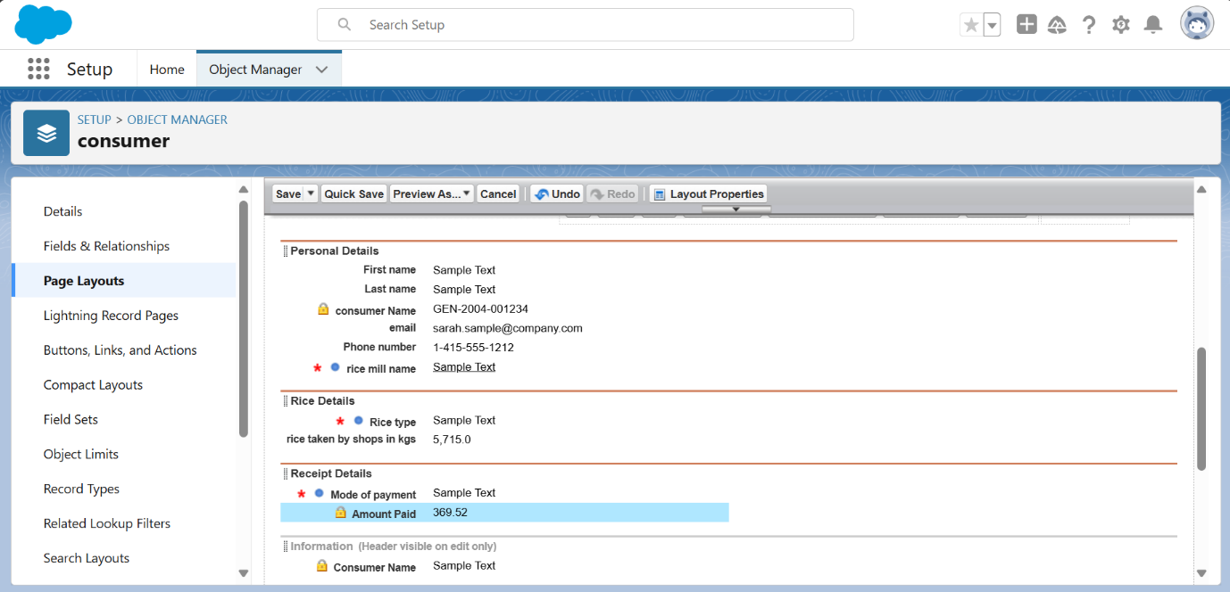**To Create a Page Layout for the Consumer Object**

1. **Navigated to the Consumer Object**
2. From the setup page, I clicked on "Object Manager."
   1. Searched for the "Consumer" object and selected it from the dropdown.
3. **Created a New Page Layout**
   1. Clicked on "Page Layouts."
   2. Clicked on "New."
4. **Configured the Page Layout**
   1. Selected the existing page layout.
   2. Entered the Page Layout Name as "Customer Layout."
   3. Clicked "Save."
5. **Created and Configured the "Personal Details" Section**
   1. Dragged and dropped the section field to the Consumer details area.
   2. Named the section "Personal Details" and clicked "Ok."
6. **Added Fields to "Personal Details" Section**
   1. Dragged and dropped the following fields into the "Personal Details" section:
      * First Name
      * Last Name
      * Consumer Name
      * Phone Number
      * Email
      * Rice Mill Name
7. **Created and Configured the "Rice Details" Section**
   1. Created a new section named "Rice Details" and clicked "Ok."
   2. Dragged and dropped the following fields into the "Rice Details" section:
      * Rice Taken by Shop
      * Rice Type
8. **Created and Configured the "Receipt Details" Section**
   1. Created a new section named "Receipt Details" and clicked "Ok."
   2. Dragged and dropped the following fields into the "Receipt Details" section:
      * Mode of Payment
      * Amount Paid
9. **Saved the Page Layout**
   1. Clicked "Save" to save the new customer Layout.

**Milestone 7 : Profiles**

**Activity 1: Creating the Owner Profile**

1. **Navigated to Profiles**
   1. From the setup page, I typed "Profiles" in the Quick Find box and clicked on "Profiles."
2. **Cloned the Standard User Profile**
   1. Selected the "Standard User" profile and clicked "Clone."
   2. Entered the Profile Name as "Owner."
   3. Clicked "Save."
3. **Configured Custom Object Permissions**
   1. Scrolled down to "Custom Object Permissions."
4. Gave access permissions for the following objects:
   * Consumers
   * Rice Details
   * Rice Mill
   * Suppliers
5. Configured permissions according to the image provided.

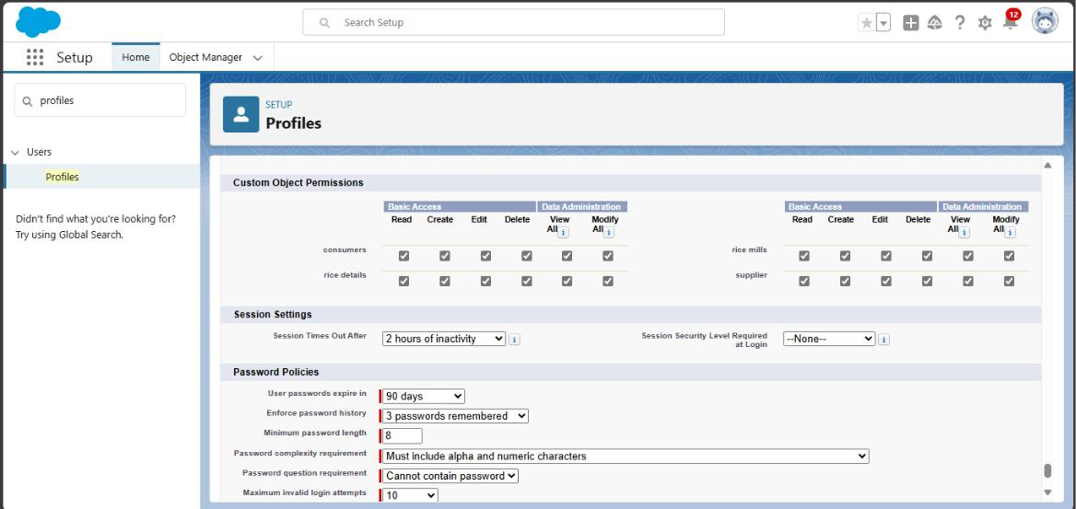

1. **Saved the Profile**
2. Clicked "Save" to apply the permissions.

**Activity 2: Creating the Employer Profile**

1. **Navigated to Profiles**
   1. From the setup page, I typed "Profiles" in the Quick Find box and clicked on "Profiles."
2. **Cloned the Standard Platform User Profile**
   1. Selected the "Standard Platform User" profile and clicked "Clone."
   2. Entered the Profile Name as "Employer."
   3. Clicked "Save."
3. **Edited the Profile Settings**
   1. While still on the profile page, clicked "Edit."
4. **Configured Custom App Settings**
   1. Selected the Custom App settings as default for the Rice Mill.
5. **Configured Custom Object Permissions**
   1. Scrolled down to "Custom Object Permissions."
6. Gave access permissions for the following objects:
   * Consumers
   * Rice Details
   * Rice Mill
   * Suppliers
7. Configured permissions according to the image provided.

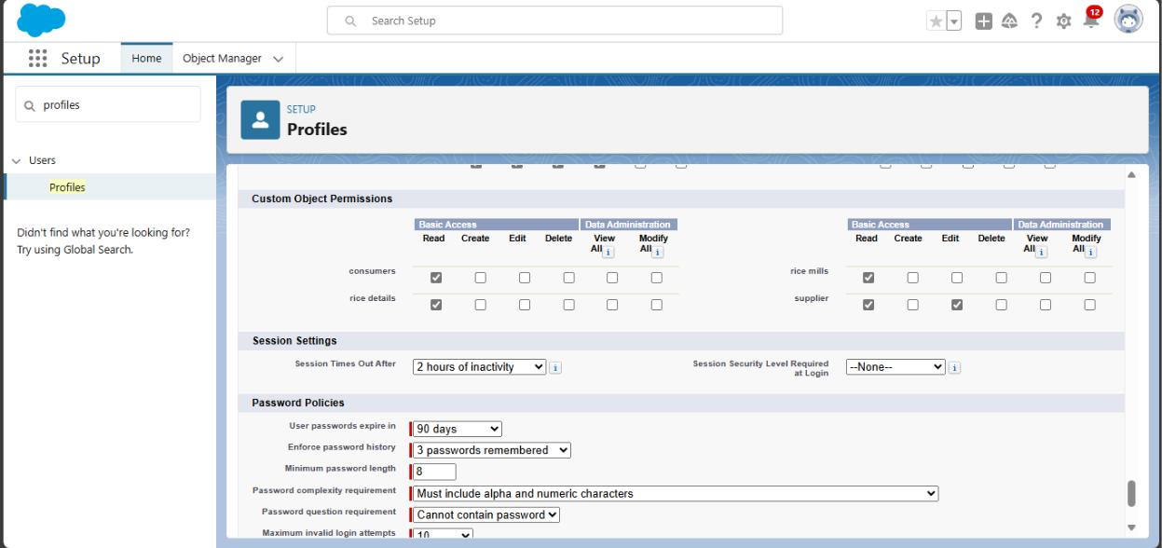

1. **Saved the Profile**
2. Clicked "Save" to apply the permissions.

**Activity 3: Creating the Worker Profile**

1. **Navigated to Profiles**
   1. From the setup page, I typed "Profiles" in the Quick Find box and clicked on "Profiles."
2. **Cloned the Standard Platform User Profile**
   1. Selected the "Standard Platform User" profile and clicked "Clone."
   2. Entered the Profile Name as "Worker."
   3. Clicked "Save."
3. **Edited the Profile Settings**
   1. While still on the profile page, clicked "Edit."
4. **Configured Custom App Settings**
   1. Selected the Custom App settings as default for the Rice Mill.
5. **Configured Custom Object Permissions**
   1. Scrolled down to "Custom Object Permissions."
6. Gave access permissions for the following objects:
   * Consumers
   * Rice Details
   * Rice Mill
   * Suppliers
7. Configured permissions according to the image provided.

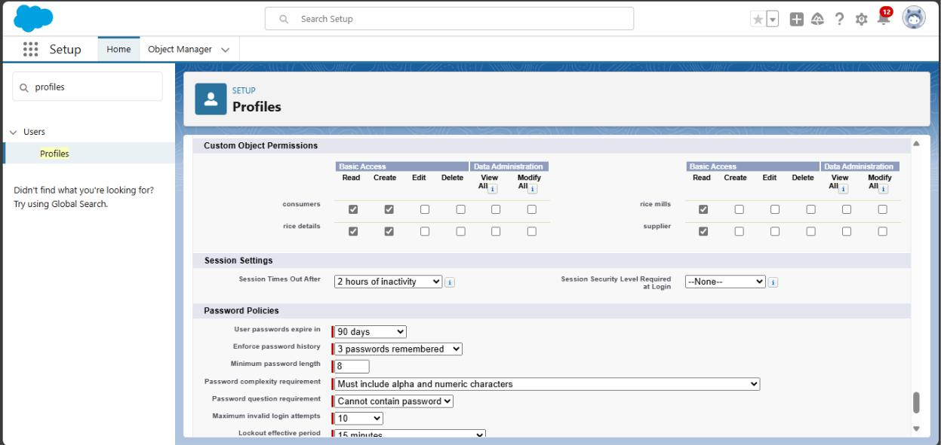

1. **Saved the Profile**
2. Clicked "Save" to apply the permissions.

the image provided.

**Milestone 8 : Role & Role Hierarchy**

**Activity 1: Creating the Owner Role**

1. **Navigated to Roles**
   1. From the setup page, I typed "Roles" in the Quick Find box and clicked on "Set Up Roles."
2. **Expanded All Roles**
   1. Clicked on "Expand All" to view the hierarchy of roles.
3. **Added the Owner Role**
   1. Clicked on "Add Role" under the role to whom this role works.
   2. Entered the Label as "Owner," and the Role Name was auto-populated.
   3. Clicked "Save."
4. **Saved the Role**
   1. Clicked "Save" to finalize the creation of the Owner role.

**Activity 2: Creating Employer and Worker Roles**

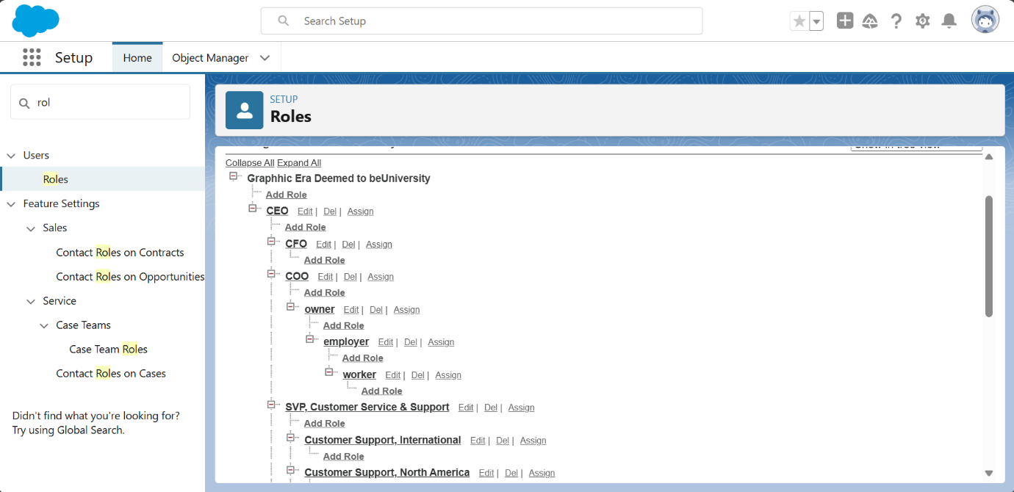

1. **Navigated to Roles**
   1. From the setup page, I typed "Roles" in the Quick Find box and clicked on "Set Up Roles."
2. **Added the Employer Role**
   1. Clicked the plus (+) sign on the CEO role.
3. Clicked "Add Role" under the Owner.
   1. Entered the Label as "Employer," and the Role Name was auto-populated.
   2. Clicked "Save."
4. **Added the Worker Role**
   1. Clicked the plus (+) sign on the CEO role.
5. Clicked the plus (+) sign on the Owner role.

o Clicked "Add Role" under the Employer.

* Entered the Label as "Worker," and the Role Name was auto-populated. o Clicked "Save."

**Milestone 9 : Users**

**Activity 1: Create User**

1. **Navigated to User Setup**
   1. From the setup page, I typed "Users" in the Quick Find box and selected "Users."
2. **Created a New User**
   1. Clicked on "New User."
3. **Filled in User Details for Vicky, Ram & Ragu one by one**

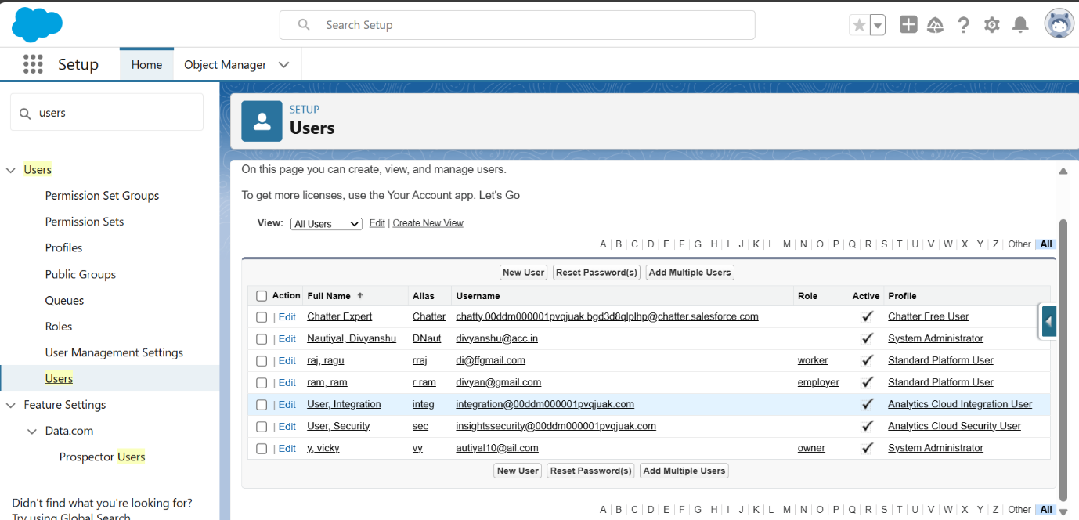

**Milestone 10 : Permission sets**

**Activity 1: Creating OWD Settings**

1. **Navigated to Sharing Settings**
   1. From the setup page, I typed "Sharing Settings" in the Quick Find box and selected it.
2. **Edited Sharing Settings**
   1. 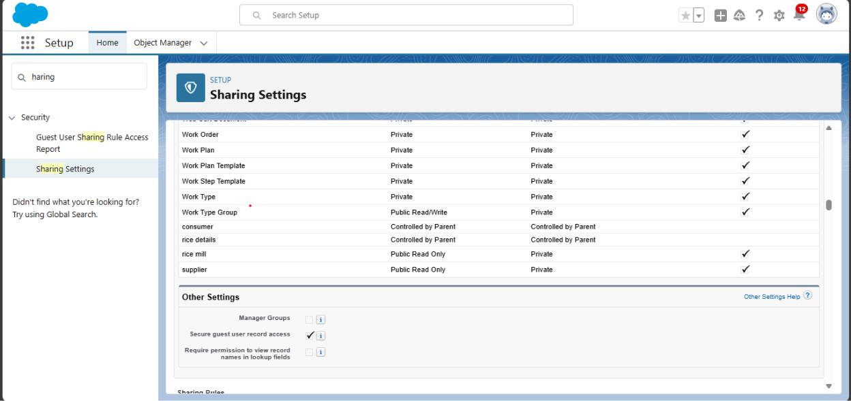Clicked on "Edit" to modify the settings.
3. **Configured Default Internal Access**
   1. Scrolled down to the section for Default Internal Access.
   2. Changed the default internal access to "Public Read-Only" for the following objects:
      * Rice Mill
      * Supplier
4. **Saved the Changes**
   1. Clicked "Save" to apply the new sharing settings.

**Milestone 11 : Reports**

**Activity 1: Create Report**

1. **Navigated to Reports**
   1. Accessed the Salesforce app and clicked on the Reports tab.
2. **Started a New Report**
   1. Clicked on "New Report."
3. **Selected Report Type**
   1. Searched for "Rice Mill with Consumers" and selected it as the report type.
   2. Clicked on "Start Report."
4. **Configured Report Columns**
   1. In the outline pane (if not already opened), selected the following fields in the Columns section:
      1. Consumer Name
      2. Rice Type
      3. Rice Price/kg
      4. Mode of Payments
      5. Amount Paid
5. **Removed Unnecessary Fields**
   1. Removed any unnecessary fields from the report layout.
6. **Grouped Rows**
   1. Selected "Rice Taken by Shops" in the GROUP ROWS section.
7. 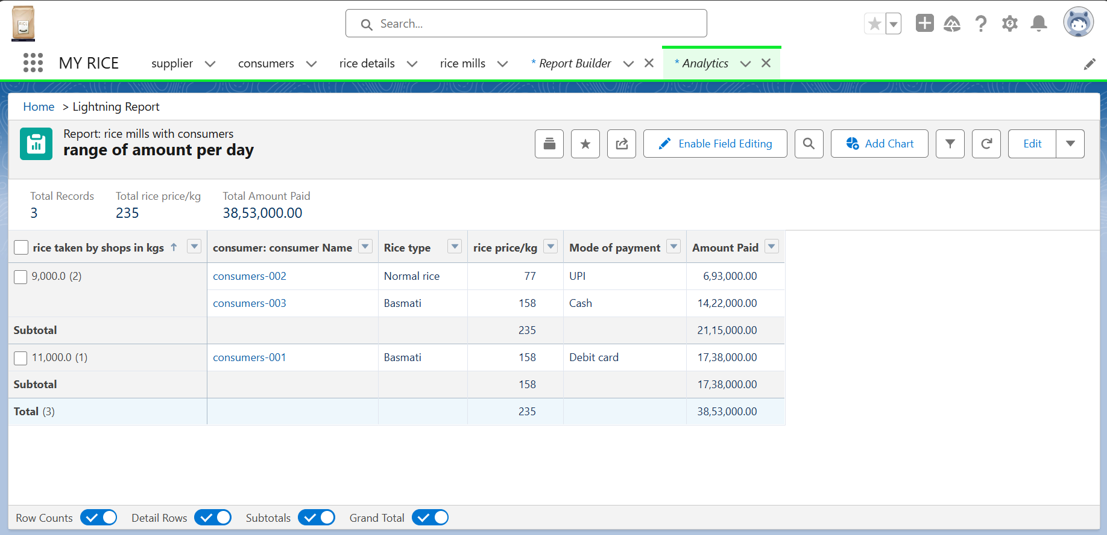**Saved and Ran the Report**
   1. Clicked "Save & Run."
8. Named the report as "Range of Amount Per Day."

o Clicked "Save."

**Activity 2: Sharing Report to Owner**

1. **Editing and Subscribing to Report**
   1. Clicked on the report's dropdown menu (edit dropdown).
   2. Selected the "Subscribe" option.
2. **Subscription Settings**
   1. Configured subscription settings as per the provided instructions.
3. **Saved the Subscription**
   1. Clicked "Save" to save the subscription settings.

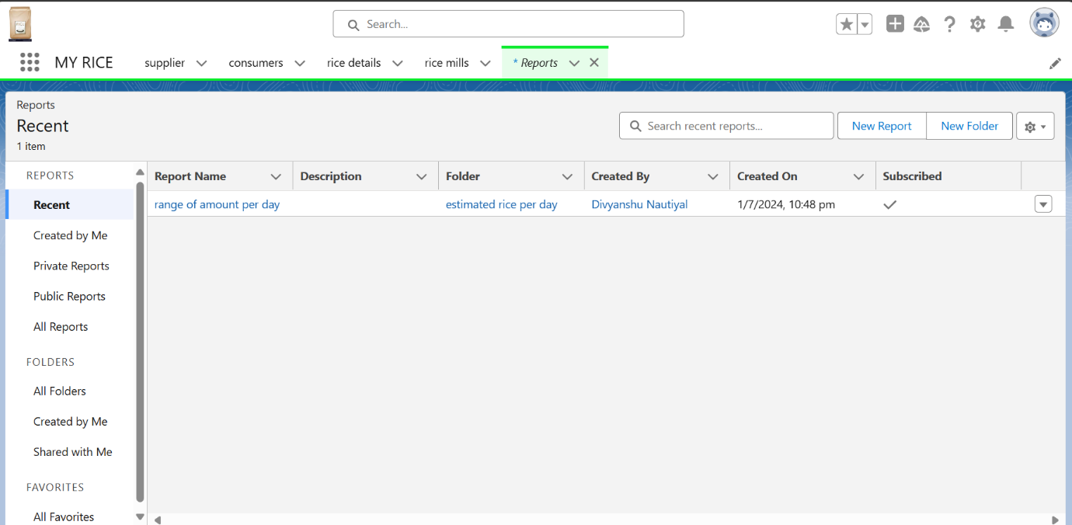**Activity 3: Create a Report Folder**

1. **Navigated to Report Folders**
   1. Clicked on the App Launcher and searched for "Reports."
2. **Opened Reports Tab**
   1. Double-clicked on the "Reports" tab, which auto-populated in the navigation bar.
3. **Created a New Folder**
   1. Clicked on "New Folder."
4. **Configured Folder Details**
   1. Gave the Folder Label as "Estimated Rice Per Day."
   2. The Folder Unique Name was auto-populated.
5. **Saved the Folder**
   1. Clicked "Save" to create and save the new report folder.

**Milestone 12 : Dashboards**

**Activity 1: Create Dashboard Folder**

1. **Navigated to Dashboard**
   1. Clicked on the App Launcher and searched for "Dashboard."
2. **Opened Dashboard Tab**
   1. Clicked on the Dashboard tab.
3. **Created a New Folder**
   1. Clicked on "New Folder" within the Dashboard interface.
4. **Configured Folder Details**
   1. Gave the Folder Label as "Amount Data Dashboard."
   2. The Folder Unique Name was auto-populated.
5. **Saved the Folder**
   1. Clicked "Save" to create and save the new dashboard folder.

**Activity 2: Create Dashboard**

1. **Navigated to Dashboards**
   1. Accessed the Salesforce app and clicked on the Dashboards tab.
2. **Started Creating a New Dashboard**
   1. Entered a Name for the dashboard.
3. Selected the previously created folder ("Amount Data Dashboard").

o Clicked on "Create."

**Adding Components to the Dashboard**

* **First Component (Vertical Bar Chart):**
* Selected "Add Component."
* Chose a Report and clicked on "Select."
* Configured the component settings:
  + Display as: Vertical Bar Chart
  + X-axis: Rice Taken by Shops
  + Y-axis: Sum of Amount
  + Y-axis Range: Automatic
  + Sort by: Rice Taken by Shops
  + Component Theme: Dark

1. **Second Component (Donut Chart):**
   * Selected "Add Component."
   * Chose a Report and clicked on "Select."
   * Configured the component settings:
     + Display as: Donut Chart
     + Sort by: Sum of Amount
     + Title: Range of Amount Per Day
     + Component Theme: Dark

